BEGIN

INPUT diem

if diem=>75

display Loai A

else

if diem >=60

display Loai B

else

if diem >= 45

display Loai C

else

if diem >= 35

display Loai C

else display Loai D

END

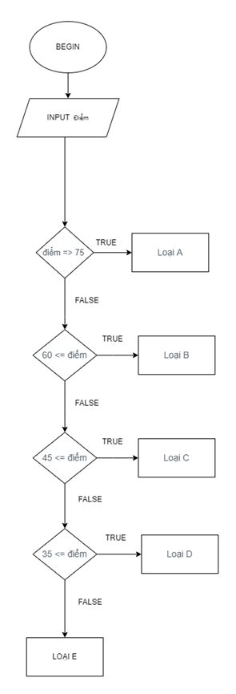

end